**Title**

An experimental framework for determining the degree of intraguild predation in a three-species terrestrial omnivorous arthropod food web in the field

**Author name and affiliation**

Gen-Chang Hsua

aDepartment of Life Science, National Taiwan University, Taipei, Taiwan

aNo.1, Sec. 4, Roosevelt Rd., Taipei 10617, Taiwan (R.O.C.)

**Corresponding author**

Gen-Chang Hsu

Address: No.1, Sec. 4, Roosevelt Rd., Taipei 10617, Taiwan (R.O.C.)

Phone: (+886) 952942842

Email: [genchanghsu@gmail.com](mailto:genchanghsu@gmail.com)

ORCID: <https://orcid.org/0000-0002-6607-4382>

**Abstract**

1. Intraguild predation (IGP) is common in natural and human-managed systems and plays a critical role in food web dynamics. Previous studies have documented the occurrence of IGP across a wide range of arthropod predator taxa, yet there is still a lack of quantitative understanding regarding the degree/intensity of IGP in these systems.
2. I propose an experimental framework combining controlled feeding trials and stable isotope analysis to determine the degree of IGP in a three-species terrestrial omnivorous arthropod food web (top predator + mesopredator + shared prey) in the field. The degree of IGP is defined herein as the proportion (in number) of mesopredator consumed in the total diet (shared prey + mesopredator) of top predator. The feeding trials are used to construct a standard curve for the degree of IGP in the focal system, to which the stable isotope signatures of field samples are compared to estimate the degree of IGP in the field.
3. The proposed framework leverages the strengths of different experimental approaches to studying trophic interactions, providing a useful tool for quantifying IGP in a accurate (controlled feeding trials and standard IGP curve) and realistic (stable isotope analysis of field samples) fashion.
4. If proven successful, the current framework can be extended to food webs involving more complex interactions (e.g., cannibalism and multiple shared prey) and further complemented with other approaches (e.g., molecular gut content analysis) to capture a more complete picture of IGP dynamics in the field.

**Key words**

intraguild predation, food webs, terrestrial arthropods, stable isotope analysis, trophic interactions, feeding experiment

**Introduction**

Intraguild predation (IGP) is common in natural and human-managed ecosystems (Polis & Holt, 1992; Müller & Brodeur, 2002; Arim & Marquet, 2004) and has been documented across a wide range of arthropod predator taxa (Polis et al., 1989; Gagnon et al., 2011). IGP could substantially affect the abundance and distribution of interacting species, generating ecological and evolutionary consequences for food web dynamics (Polis et al., 1989).

Previous studies have demonstrated the occurrence of IGP among arthropod predators through field observations of diet compositions (e.g., Nyffeler & Sunderland, 2003; Birkhofer & Wolters, 2012). Manipulative experiments (e.g., field cages) have also been used to assess the intensity of IGP (Denno et al., 2004; Provost et al., 2005) [remove Provost and add e.g., ], which could reveal the mechanisms underlying predator-prey interactions and allow for strong causal inferences about IGP. However, the confined settings in these experiments may potentially alter the encounter rates between organisms, thus leading to biased results (Uiterwaal et al., 2019).

Stable isotopes, particularly nitrogen isotope signatures (δ15N), have been used to estimate the trophic level of predators in the field for inferences about IGP (Halaj et al., 2005; Wise et al., 2006; Sanders & Platner, 2007) [remove Halaj and Sanders and add e.g., ]. It is suggested that IGP would increase the δ15N of predators (Ponsard & Arditi, 2000). For example, Rickers et al. (2006) conducted feeding experiments on wolf spiders (*Alopecosa cuneata*) and found a higher δ15N of these top predators in IGP treatment. However, the study did not quantify the degree of IGP as the IGP treatment was binary (absence vs. presence of mesopredator) with constant numbers of shared prey and mesopredator. On top of that, the trophic levels of top predators in previous studies were often calculated based on assumed trophic discrimination factors (TDFs) (e.g., Klarner et al., 2013; Svanbäck et al., 2015) [remove Klarner]. Since TDFs are quite taxon-specific (Caut et al., 2009), this could lead to incorrect trophic level estimates and inferences about IGP in the field.

Recently, researchers have applied molecular gut content analysis and immunological techniques to reliably detect the presence of certain food items in predators’ diet (Hagler, 2006; Gagnon et al., 2011; Mansfield & Hagler, 2016) [remove Hagler and Mansfield], allowing for estimating the incidence rates of IGP (i.e., the percentage of top predator individuals with mesopredator detected in the gut contents). Nonetheless, the incidence rates may not necessarily reflect the degree of IGP in the system (Raso et al., 2014). For example, it is possible that a high percentage of top predator individuals feed on mesopredator yet each consumes on average only a low proportion of mesopredator in the diet. In this case, a high incidence rate of IGP only provides an incomplete picture of IGP dynamics and could be misleading.

Quantifying IGP is a critical step towards a deeper understanding of food web dynamics. Research has attempted to predict the intensity/degree of IGP based on allometric theory (Schneider et al., 2012), yet empirical evidence remains scarce. To address this gap, I propose an experimental framework combining controlled feeding trials and stable isotope analysis of field samples to determine the degree of IGP in a three-species terrestrial omnivorous arthropod food web (top predator + mesopredator + shared prey). The degree of IGP is defined herein as the proportion (in number) of mesopredator consumed in the total diet (mesopredator + shared prey) of top predator. The feeding trials will experimentally link different levels of mesopredator consumption by top predators to the changes in their nitrogen isotope signatures (δ15N) via a standard curve, to which the isotope signatures of field samples are compared to estimate the degree of IGP in the field.

**Materials and Methods**

Here, I illustrate the proposed framework using an example of a terrestrial arthropod food web involving a spider top predator, a spider mesopredator, and a planthopper shared prey (Fig. 1a). Two sets of controlled feeding trials will be conducted. In the first trial, the top predator and the mesopredator are fed the shared prey (Fig. 1b). As invertebrates may exhibit rapid tissue turnover, a period of 5–10 days will allow predators to incorporate isotope signatures into their tissues and reach an isotopic equilibrium state with the shared prey (Quinby et al., 2020). In the second trial (same duration as the first trial), the top predator is fed mixed diets with different proportions of mesopredator and shared prey individuals from the first trial: (1) shared prey only, (2) 75% of shared prey + 25% of mesopredator, (3) 50% of shared prey + 50% of mesopredator, (4) 25% of shared prey + 75% of mesopredator, and (5) mesopredator only (Fig. 1c). The numbers of mesopredator and shared prey in the supplied diet can be determined based on their field densities. The purpose of this trial is to simulate a full range of potential encounter rates that the focal organisms might experience in the field.

At the end of the second trial, the numbers of mesopredator and shared prey consumed by the top predator in each diet treatment are recorded, and the differences in δ15N values between the top predator individuals and the shared prey (baseline) are computed (δ15N*predator*─ δ15N*prey*; Δ15N). A standard curve can be constructed by plotting the experimental Δ15N of top predator against the proportion of mesopredator consumed (Fig. 1d). Finally, field samples of top predator and shared prey individuals are collected, with their δ15N analyzed to obtain the empirical Δ15N. The degree of IGP in the field can thus be estimated by interpolating the empirical Δ15N to the standard curve (Fig. 1e). A hypothetical example of data collection in the second trial for standard curve construction is provided in Fig. 2.

**Results and Discussion**

The proposed framework leverages the strengths of previous approaches to studying IGP—the controlled feeding trials combined with stable isotope analysis can yield accurate experimental Δ15N to construct a standard curve, whereas the empirical Δ15N derived field samples reflects the trophic interactions under natural settings. Although it is possible that the isotope signatures of predators in the field may represent multiple dietary items over time and space, the framework could still provide a useful tool for assessing IGP in more quantitative and realistic fashion.

Agricultural systems, in which IGP has been frequently documented (Polis et al., 1989; Rosenheim et al., 1995), are ideal for implementing the framework. As the food webs are relatively simple compared with other natural ecosystems, the potential effects of non-focal species on the trophic interactions among focal organisms can be minimized (Vance-Chalcraft et al., 2007). Moreover, the framework can be implemented along environmental gradients or under different field treatments to examine how various abiotic and biotic factors may affect the degree of IGP in natural settings. Finally, the framework is robust to variations in background isotope signatures because the degree of IGP is determined based on the difference between nitrogen isotope signatures of the focal organisms (Δ15N) rather than their original values (δ15N), thus allowing for comparisons across sites or systems with distinct background isotope signatures.

A better quantitative understanding of IGP can provide critical insights into the complex predator-predator-prey trophic interactions and could help predict the community structure and stability (Arim & Marquet, 2004; Pahl et al., 2020) [remove Nakazawa]. Furthermore, such an understanding can have useful implications for practitioners, for example, evaluation of the effectiveness of biocontrol agents in pest control programs (Müller & Brodeur, 2002). If proven successful, the current framework can be extended to food webs involving more complex interactions (e.g., cannibalism and multiple shared prey) and complemented with other approaches (e.g., molecular gut content analysis) to better elucidate the IGP dynamics in the field.

**Acknowledgements**

I thank William J.-A. Ou for the useful comments and editing work on this manuscript.

**Contribution of authors**

GCH conceived the idea and wrote the manuscript. No other person was entitled to authorship.

**Conflict of interest**

The author declares no conflict of interest regarding this paper.

Reference

Arim, M. & Marquet, P.A. (2004) Intraguild predation: a widespread interaction related to species biology. *Ecology Letters*, **7**, 557-564.

Birkhofer, K. & Wolters, V. (2012) The global relationship between climate, net primary production and the diet of spiders, Vol. 21, pp. 100-108. Wiley Online Library.

Caut, S., Angulo, E., & Courchamp, F. (2009) Variation in discrimination factors (Δ15N and Δ13C): the effect of diet isotopic values and applications for diet reconstruction. *Journal of Applied Ecology*, **46**, 443-453.

Denno, R.F., Mitter, M.S., Langellotto, G.A., Gratton, C., & Finke, D.L. (2004) Interactions between a hunting spider and a web‐builder: consequences of intraguild predation and cannibalism for prey suppression. *Ecological entomology*, **29**, 566-577.

Gagnon, A.-È., Heimpel, G.E., & Brodeur, J. (2011) The ubiquity of intraguild predation among predatory arthropods. *PLoS One*, **6**, e28061.

Hagler, J. (2006) Development of an immunological technique for identifying multiple predator–prey interactions in a complex arthropod assemblage. *Annals of Applied Biology*, **149**, 153-165.

Halaj, J., Peck, R.W., & Niwa, C.G. (2005) Trophic structure of a macroarthropod litter food web in managed coniferous forest stands: a stable isotope analysis with δ15N and δ13C. *Pedobiologia*, **49**, 109-118.

Klarner, B., Maraun, M., & Scheu, S. (2013) Trophic diversity and niche partitioning in a species rich predator guild–Natural variations in stable isotope ratios (13C/12C, 15N/14N) of mesostigmatid mites (Acari, Mesostigmata) from Central European beech forests. *Soil Biology and Biochemistry*, **57**, 327-333.

Mansfield, S. & Hagler, J.R. (2016) Wanted dead or alive: scavenging versus predation by three insect predators. *Food Webs*, **9**, 12-17.

Müller, C.B. & Brodeur, J. (2002) Intraguild predation in biological control and conservation biology. *Biological Control*, **25**, 216-223.

Nakazawa, T. & Yamamura, N. (2006) Community structure and stability analysis for intraguild interactions among host, parasitoid, and predator. *Population Ecology*, **48**, 139-149.

Nyffeler, M. & Sunderland, K.D. (2003) Composition, abundance and pest control potential of spider communities in agroecosystems: a comparison of European and US studies. *Agriculture, Ecosystems & Environment*, **95**, 579-612.

Pahl, K.B., Yurkowski, D.J., Lees, K.J., & Hussey, N.E. (2020) Measuring the occurrence and strength of intraguild predation in modern food webs. *Food Webs*, e00165.

Polis, G.A. & Holt, R.D. (1992) Intraguild predation: the dynamics of complex trophic interactions. *Trends in ecology & evolution*, **7**, 151-154.

Polis, G.A., Myers, C.A., & Holt, R.D. (1989) The ecology and evolution of intraguild predation: potential competitors that eat each other. *Annual review of ecology and systematics*, **20**, 297-330.

Ponsard, S. & Arditi, R. (2000) What can stable isotopes (δ15N and δ13C) tell about the food web of soil macro‐invertebrates? *Ecology*, **81**, 852-864.

Provost, C., Coderre, D., Lucas, E., Chouinard, G., & Bostanian, N.J. (2005) Impact of intraguild predation and lambda‐cyhalothrin on predation efficacy of three acarophagous predators. *Pest Management Science: formerly Pesticide Science*, **61**, 532-538.

Quinby, B.M., Creighton, J.C., & Flaherty, E.A. (2020) Stable isotope ecology in insects: a review. *Ecological Entomology*, **45**, 1231-1246.

Raso, L., Sint, D., Mayer, R., Plangg, S., Recheis, T., Brunner, S., Kaufmann, R., & Traugott, M. (2014) Intraguild predation in pioneer predator communities of alpine glacier forelands. *Molecular ecology*, **23**, 3744-3754.

Rickers, S., Langel, R., & Scheu, S. (2006) Stable isotope analyses document intraguild predation in wolf spiders (Araneae: Lycosidae) and underline beneficial effects of alternative prey and microhabitat structure on intraguild prey survival. *Oikos*, **114**, 471-478.

Rosenheim, J.A., Kaya, H.K., Ehler, L.E., Marois, J.J., & Jaffee, B.A. (1995) Intraguild predation among biological-control agents: theory and evidence. *Biological control*, **5**, 303-335.

Sanders, D. & Platner, C. (2007) Intraguild interactions between spiders and ants and top-down control in a grassland food web. *Oecologia*, **150**, 611.

Schneider, F.D., Scheu, S., & Brose, U. (2012) Body mass constraints on feeding rates determine the consequences of predator loss. *Ecology letters*, **15**, 436-443.

Svanbäck, R., Quevedo, M., Olsson, J., & Eklöv, P. (2015) Individuals in food webs: the relationships between trophic position, omnivory and among-individual diet variation. *Oecologia*, **178**, 103-114.

Uiterwaal, S.F., Dell, A.I., & DeLong, J.P. (2019) Arena size modulates functional responses via behavioral mechanisms. *Behavioral Ecology*, **30**, 483-489.

Vance-Chalcraft, H.D., Rosenheim, J.A., Vonesh, J.R., Osenberg, C.W., & Sih, A. (2007) The influence of intraguild predation on prey suppression and prey release: a meta‐analysis. *Ecology*, **88**, 2689-2696.

Wise, D.H., Moldenhauer, D.M., & Halaj, J. (2006) Using stable isotopes to reveal shifts in prey consumption by generalist predators. *Ecological Applications*, **16**, 865-876.

**Figure legends**

Figure 1.A schematic diagram of the proposed experimental framework for determining the degree of intraguild predation (IGP) in a three-species terrestrial omnivorous arthropod food web involving a spider top predator, a spider mesopredator, and a planthopper shared prey (a). In the first trial (b), the top predator and the mesopredator are fed the shared prey for 5–10 days to ensure an isotopic equilibrium state between the predators and the prey. In the second trial (c), the top predator is fed mixed diets with different proportions of mesopredator and shared prey individuals to simulate a full range of potential encounter rates that the focal organisms might experience in the field. (d) A standard curve can be constructed by plotting the difference in nitrogen isotope signatures between the top predator individuals and the shared prey (baseline) (δ15N*predator*─ δ15N*prey*; experimental Δ15N) against the proportion of mesopredator consumed. Note that the curve may not necessarily be linear due to biomass differences between mesopredator and shared prey. (e) The δ15N of field-sampled top predator and shared prey individuals are analyzed to obtain the empirical Δ15N, which is then interpolated to the standard curve to estimate the degree of IGP in the field.

Figure 2. A hypothetical example of data collection in the second trial for standard curve construction. Each diet treatment consists of five replicates (i.e., five different top predator individuals). *N*: number of shared prey/mesopredator supplied in the mixed diet; *C*: number of shared prey/mesopredator consumed by the top predators; *P*: proportion of mesopredator consumed (%). Each point in the standard curve represents a top predator individual.

**Figures**

Figure 1.

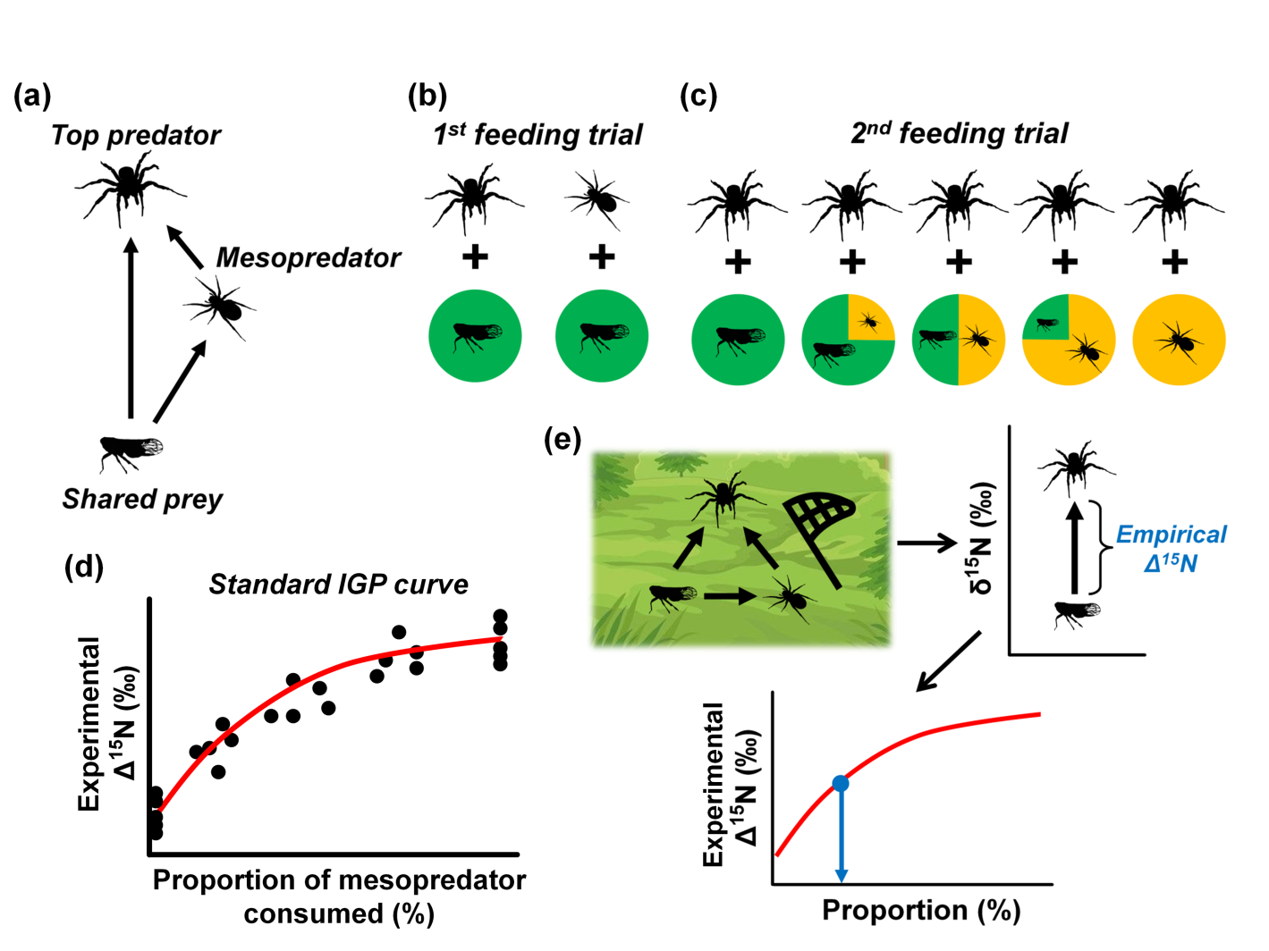

Figure 2.

